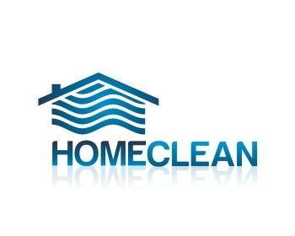
Terms and conditions of business

Homeclean acts as an introduction agency between clients and cleaners. On payment of an agency fee Homeclean will contract to introduce domestic cleaners to the client to clean one property only for the time period stated on the invoice.

At all times the cleaners are under the client’s supervision, control and responsibility. They are not employed by the agency, either directly or indirectly, but are self-employed.

The company does not accept any responsibility whatsoever for any loss, expense, damage arising from any act or omission by the introduced cleaner.

The company will make every effort to obtain suitable references and ensure that the cleaners so provided under the terms of this contract are competent work people but no responsibility is to be attached to the company as a result of a failure of the selection procedure for any reason.

Should the introduced cleaner refuse without cause to comply with the reasonable terms of the client, fall ill, go on holiday or leave for any reason whatsoever, then the company will undertake to supply free of charge a replacement cleaner at the earliest opportunity and in any event within 10 days of notification of the departure of the original introduced cleaner.

The client will be responsible at all times for payment of the cleaner, the supply of cleaning materials and equipment and arrangements for access to the client’s home.

This contract shall last for the period of time specified on the contract but should the introduced cleaner or replacement, introduced either by the original cleaner or the agency remain providing services to the client for any length of time whatsoever over the period of time covered by the contract then the client agrees to pay a further fee to the agency for each year or part of the year so covered.

Should the client wish to terminate the contract then they should give the company one months notice in writing of termination.

The agency will offer no refunds once a cleaner has been taken on.

